Nama : Revan Febriansyah

NIM :18090091

Kelas : 5D

**PRAKTIKUM 5**

1. Source Code

Autoload.php => application / config

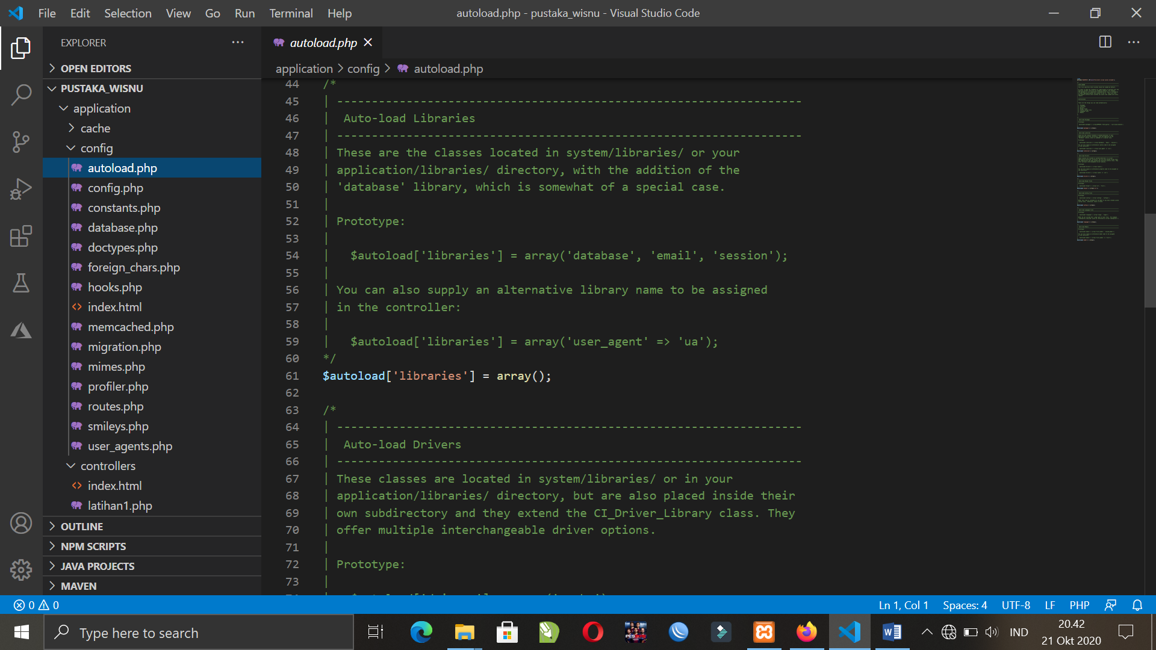

MatakuliahValidation.php => application / controller

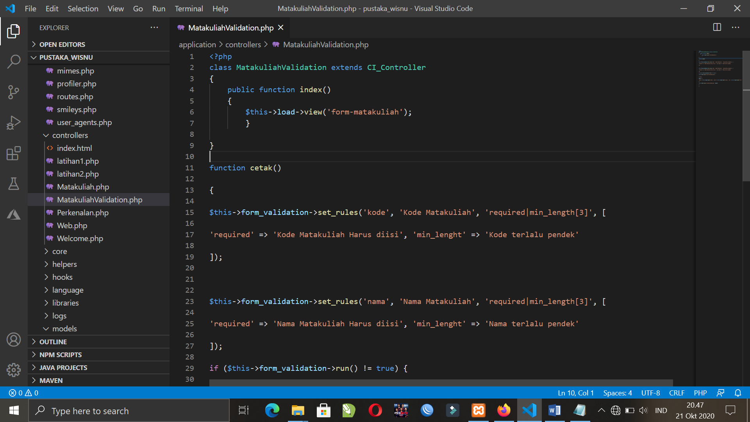

form-matakuliah.php => application / views

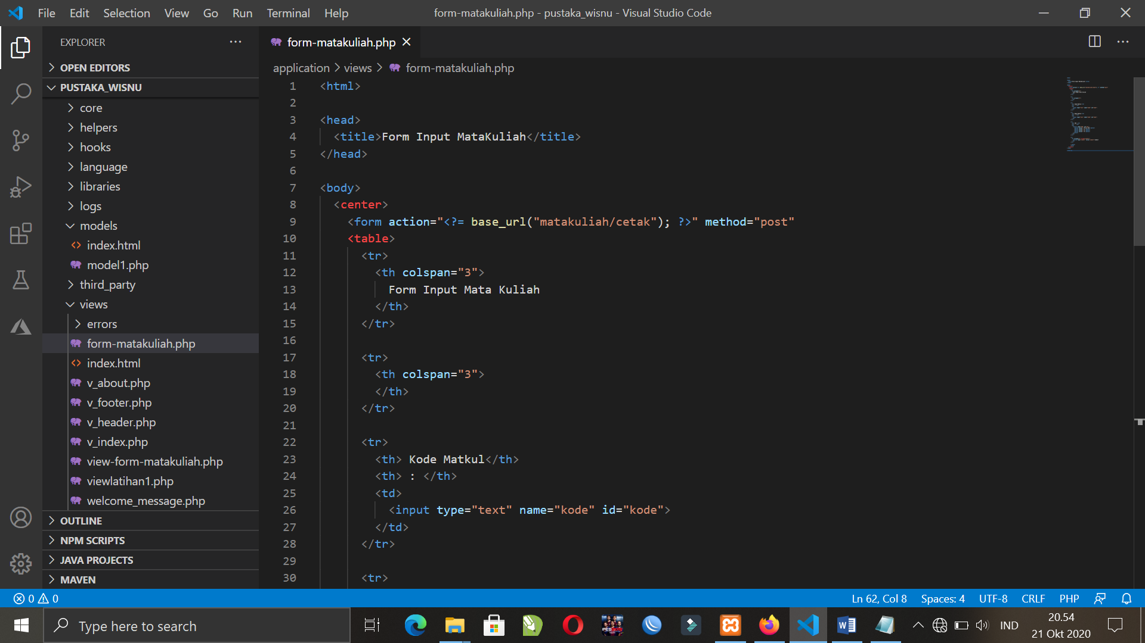

1. URL

<http://localhost/pustaka_revan/index.php/MatakuliahValidation>

1. Capture Hasil

